POWER BI
ASSIGNMENT 1
DATA TRANSFORMATION AND DATA MODELING
First open Power BI Desktop app and then in ribbon there’s Home tab ,click get data .There we can select csv file and select list of orders file and the n a new dialogue box open showing preview of data then click load then the data is open Power BI window .
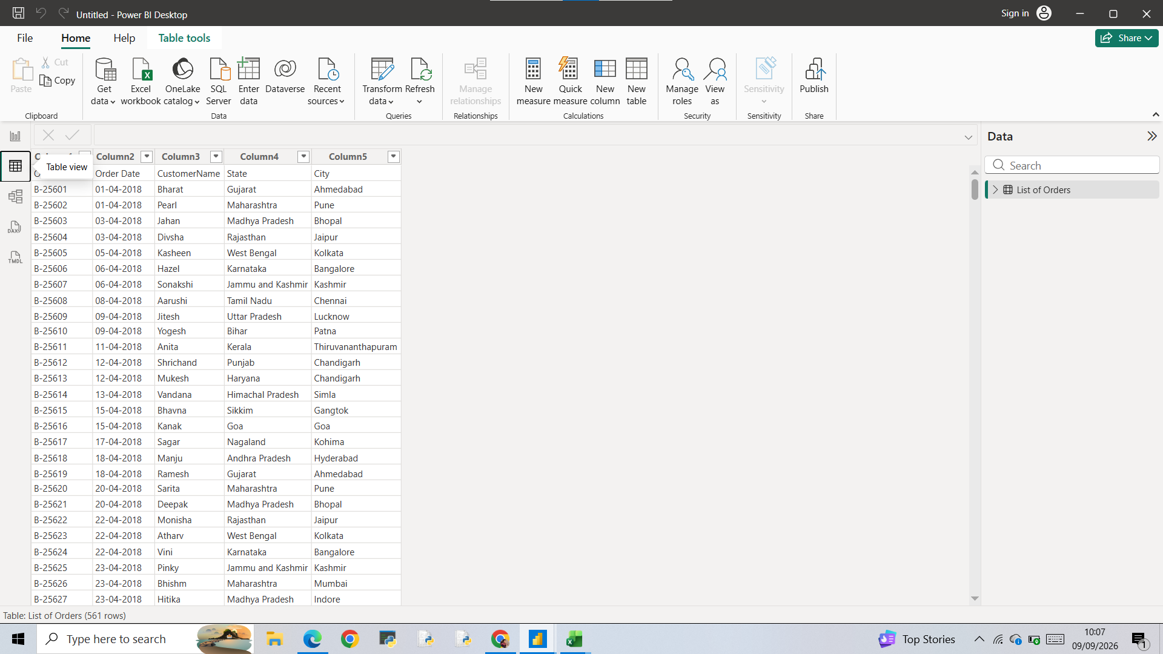

After that click Transform data then the datas are open in another window as power query editor

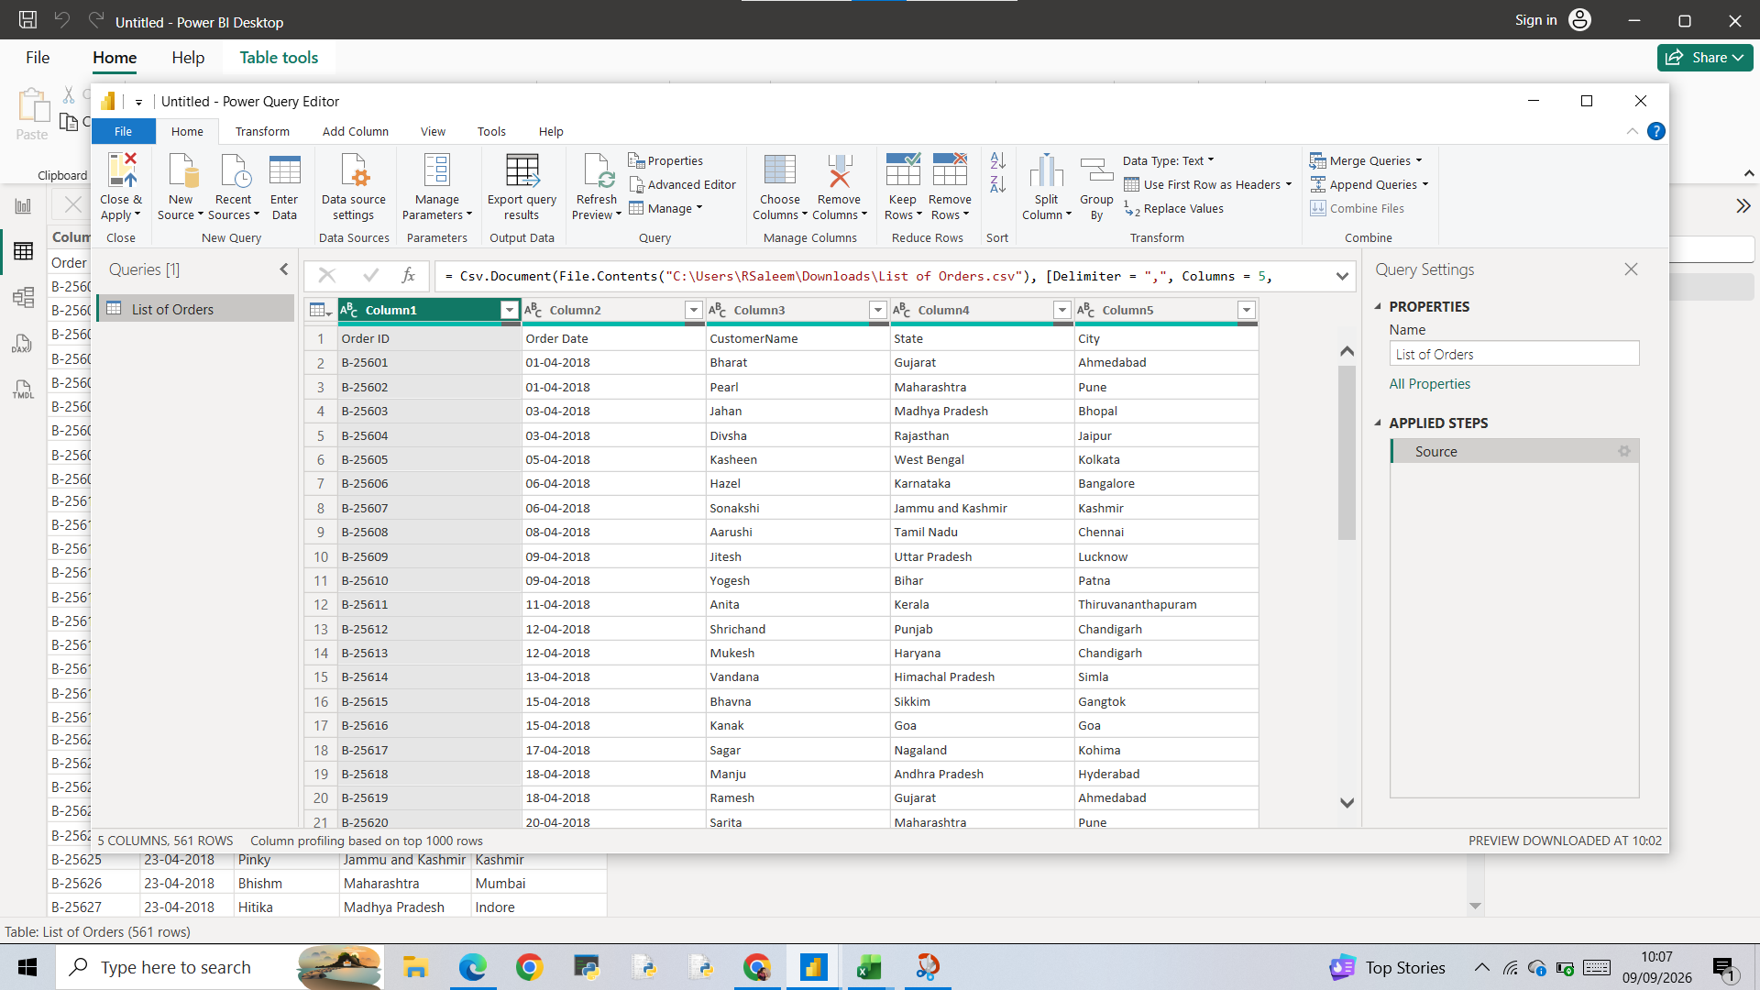

Then 2 pages import to power query editor through new source in ribbon

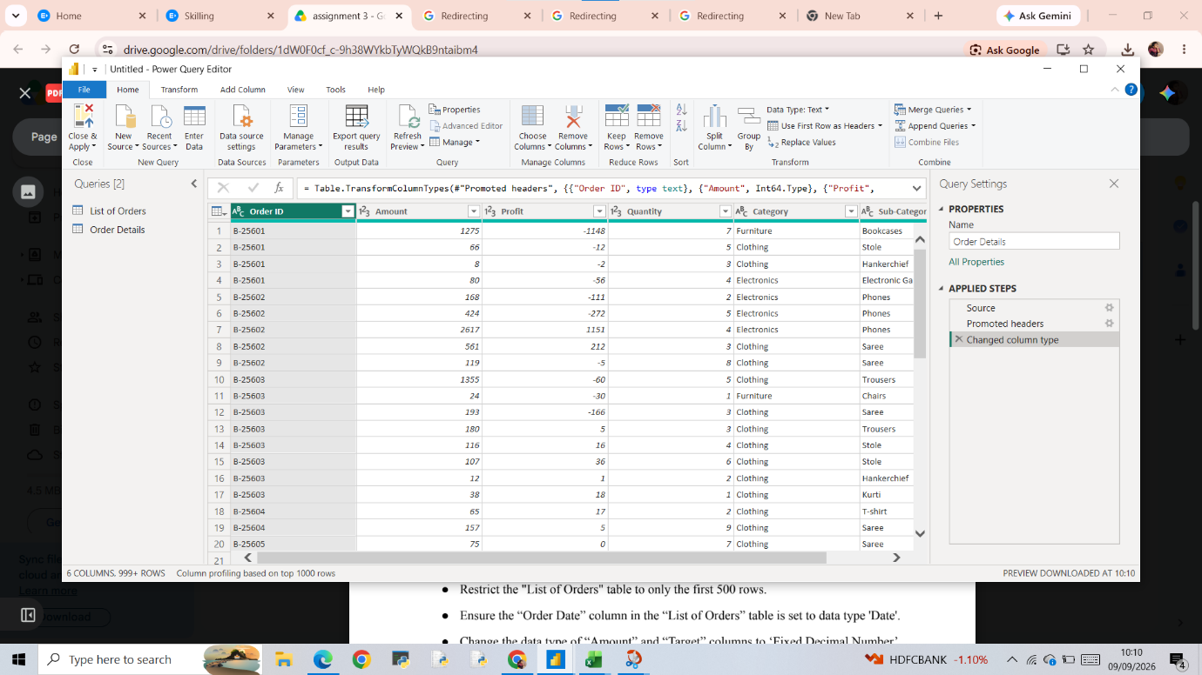

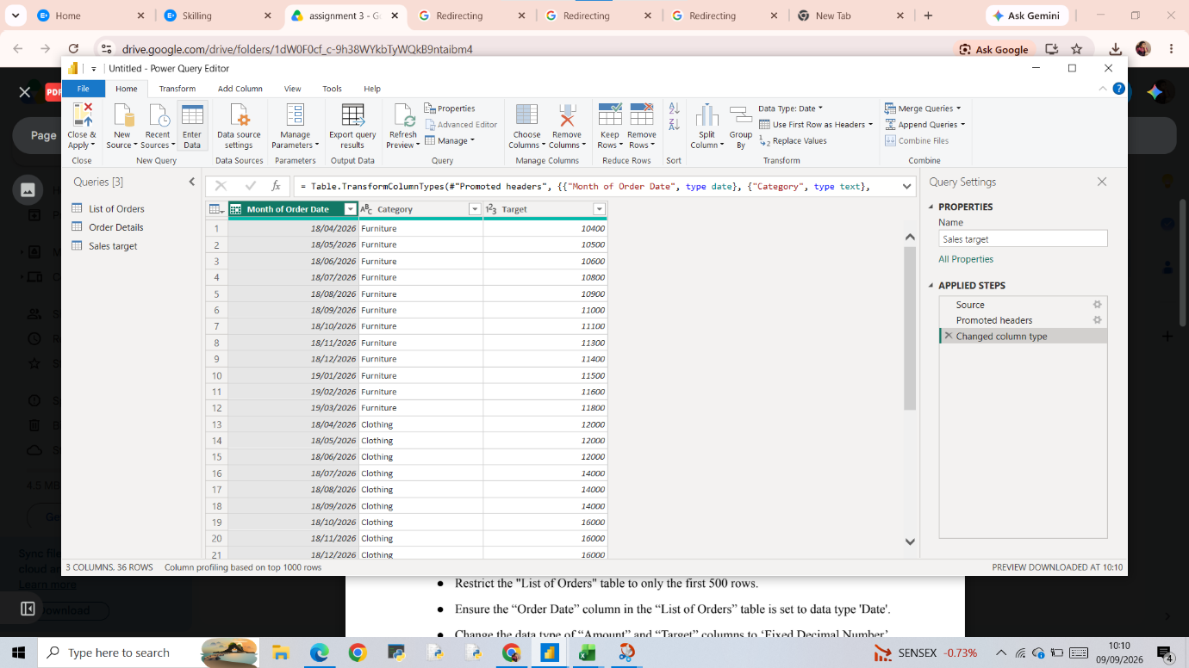

KEEP ROWS

Keep Rows –select the table –home –keep rows—keep top rows –Dialogue box appears—give numer of rows to keep –ok

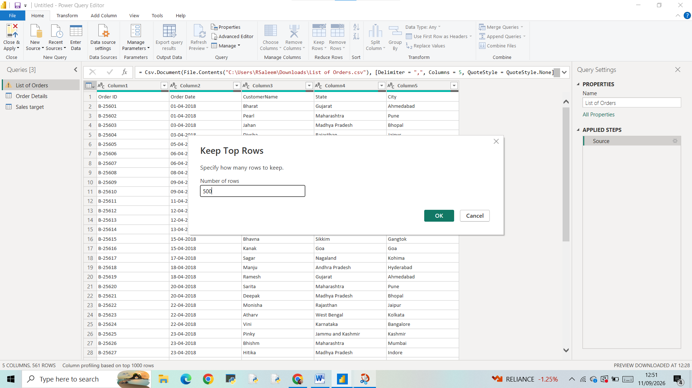
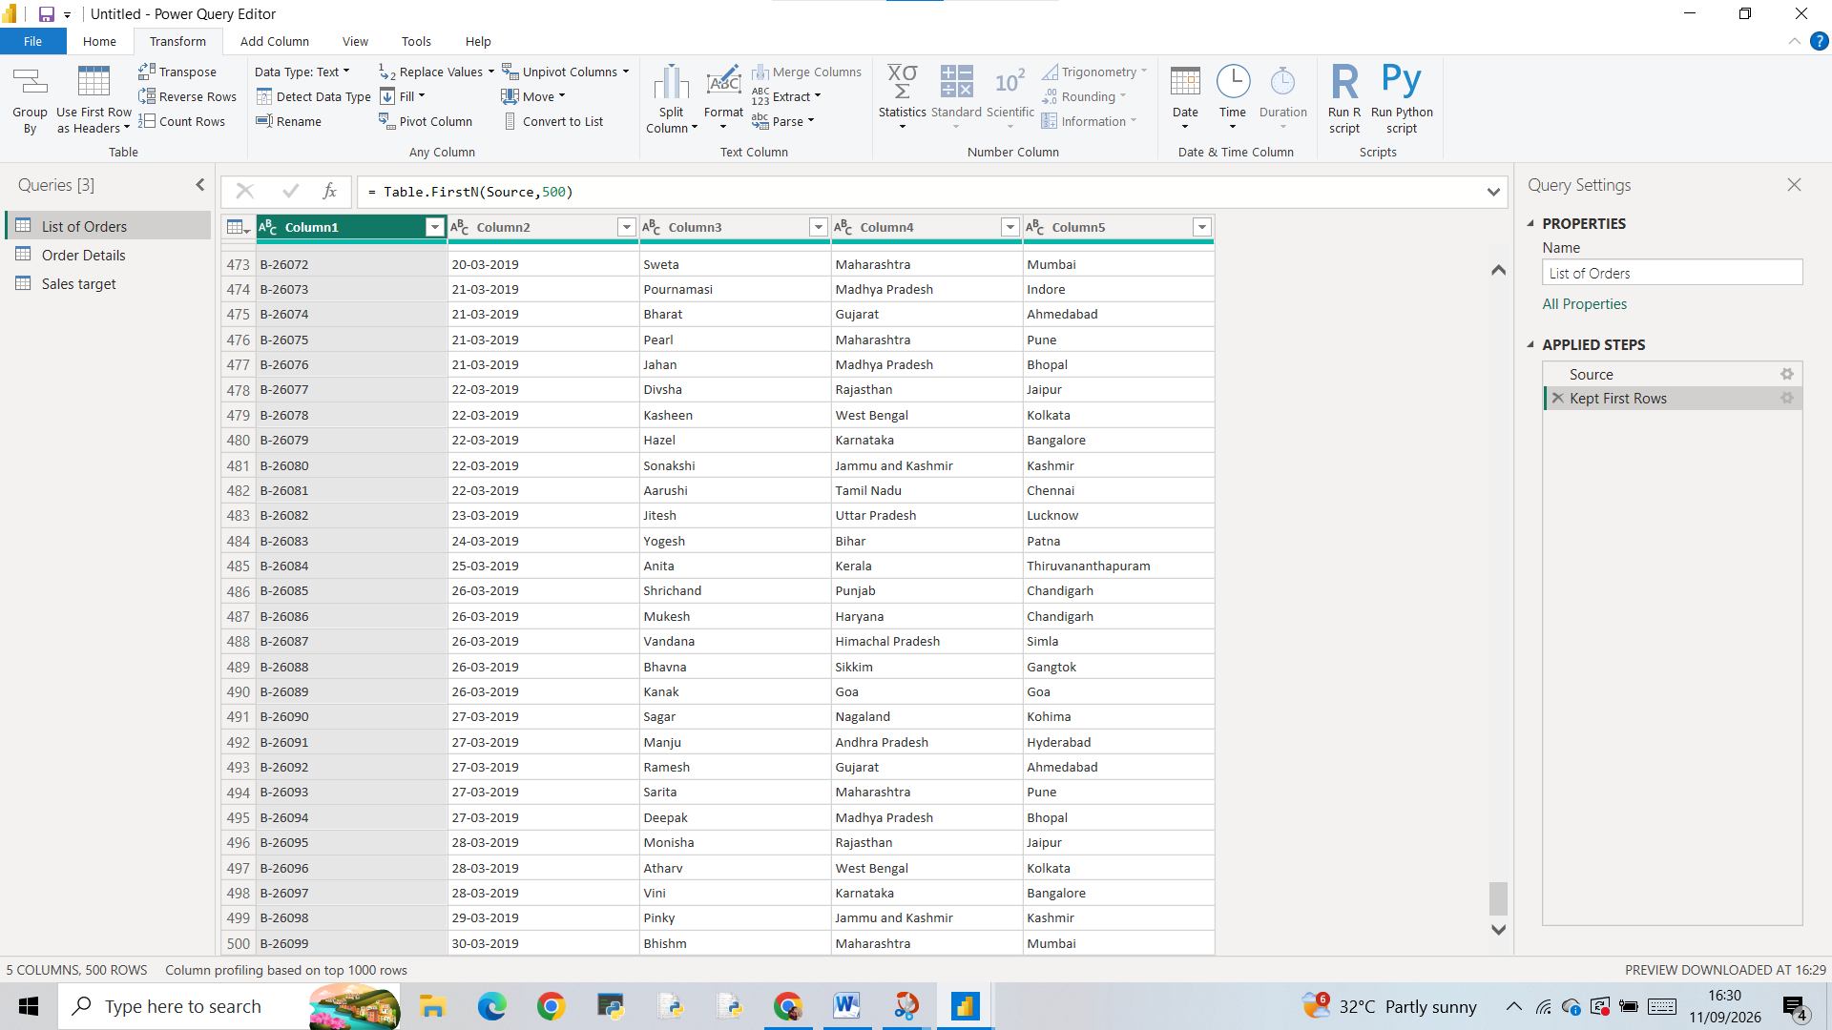

CHANGE TYPE
Change date type transform—Data type—Date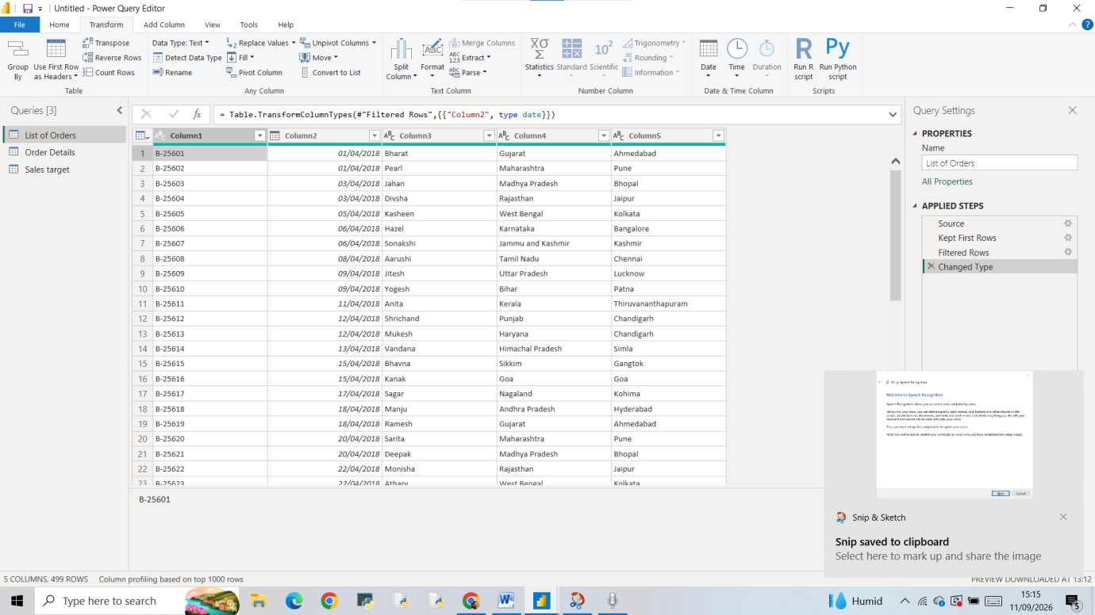

Same way also change Amount and Target column to fixed decimal number
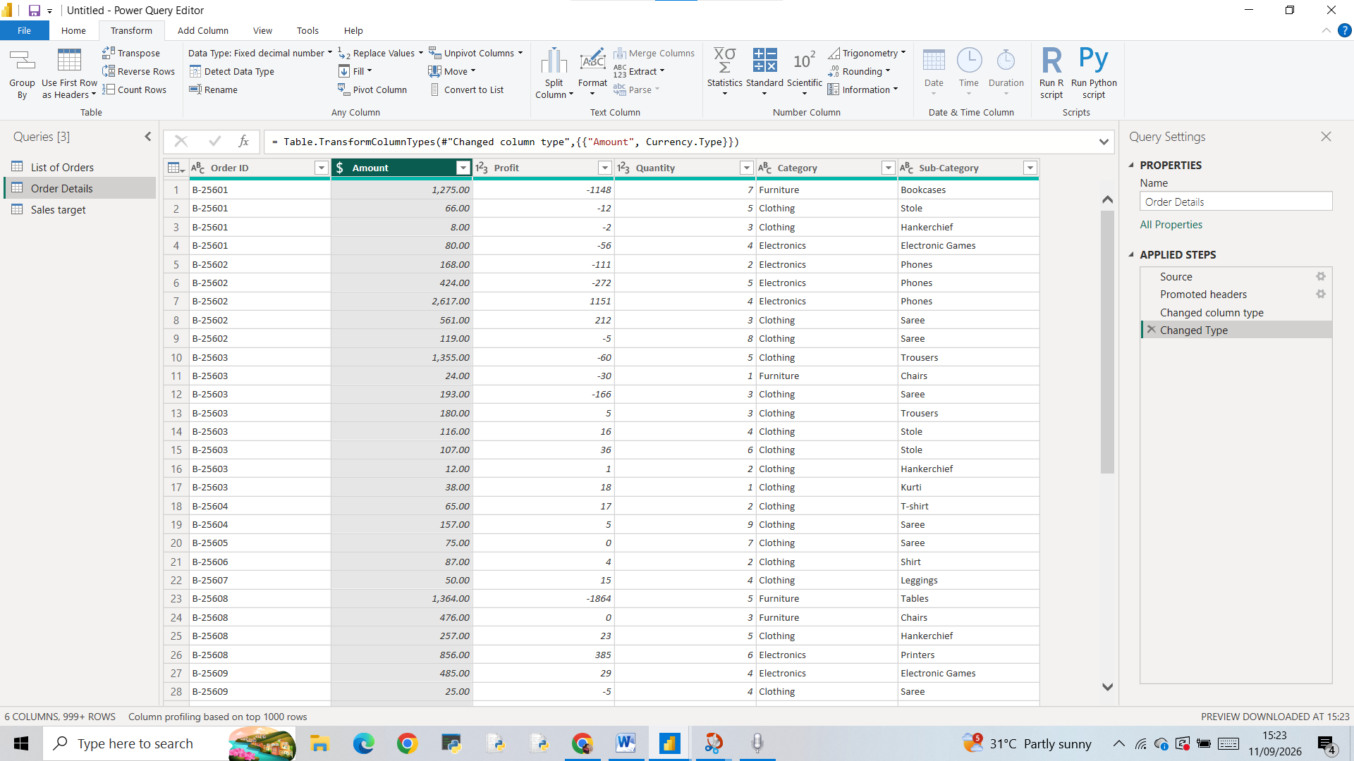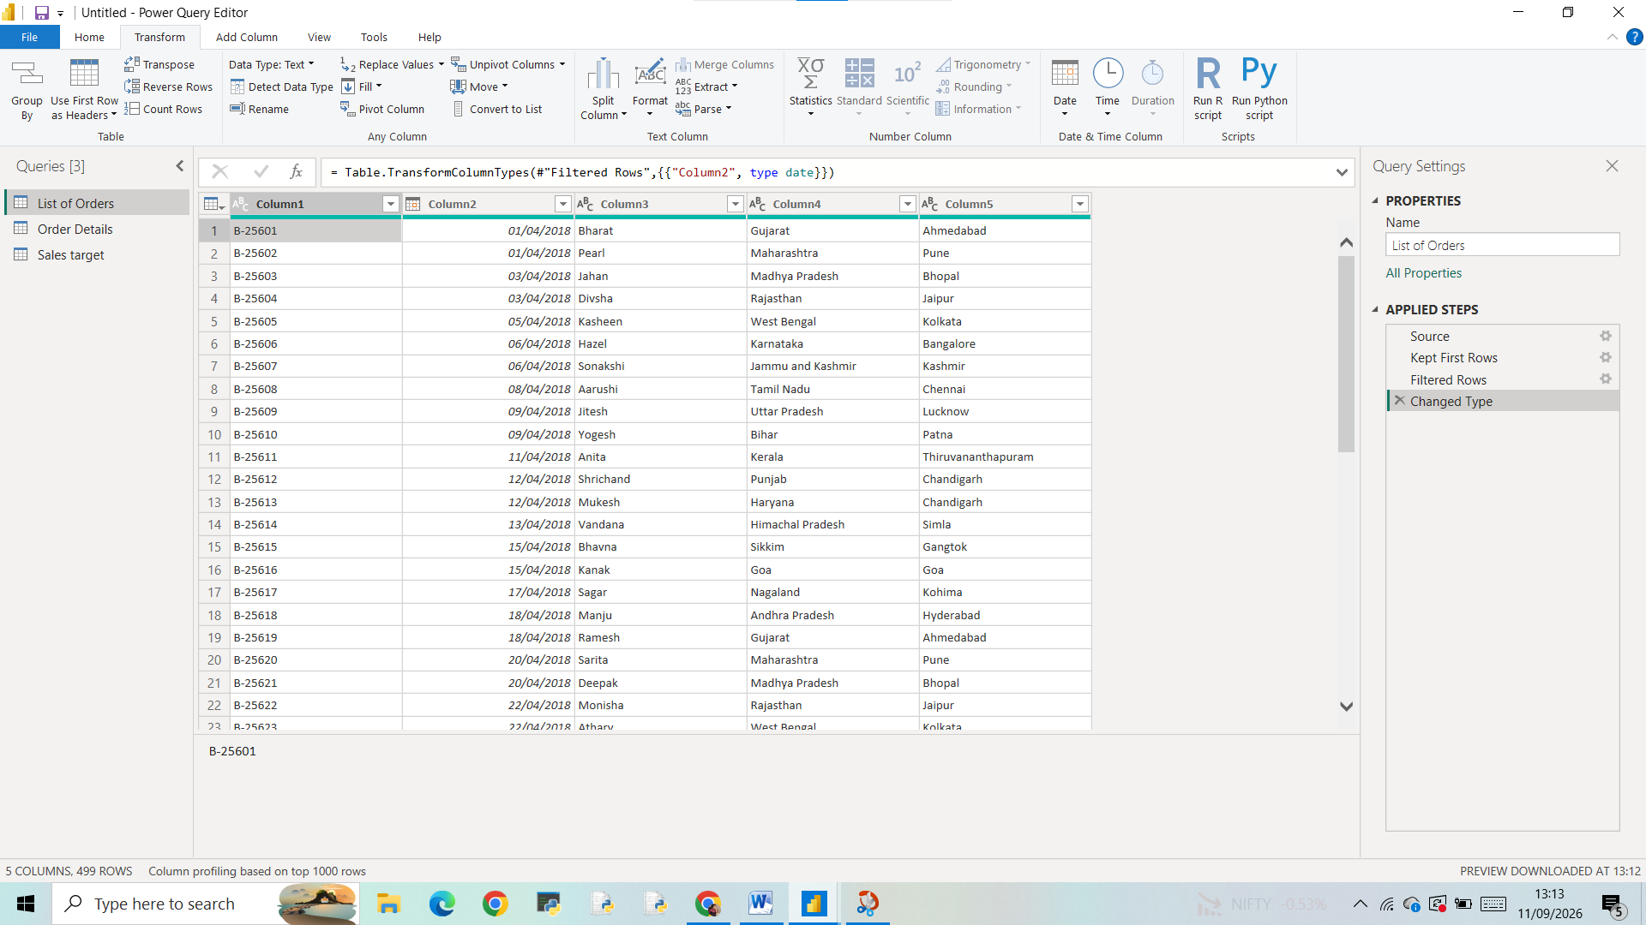

Customer Name column into Proper case
Transform—Format—Capitalize each word

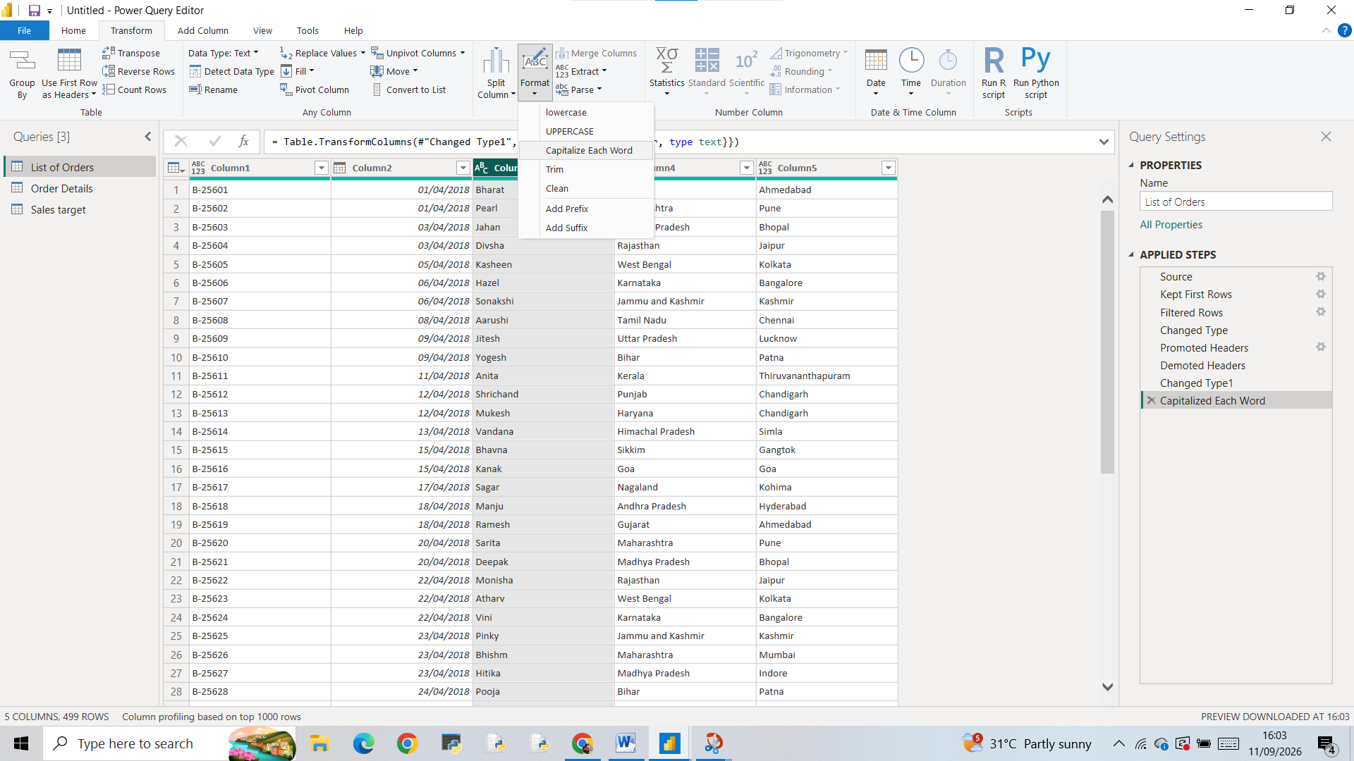

New column
Home-- Transform data –select table –merge columns—select separator—Type name –ok
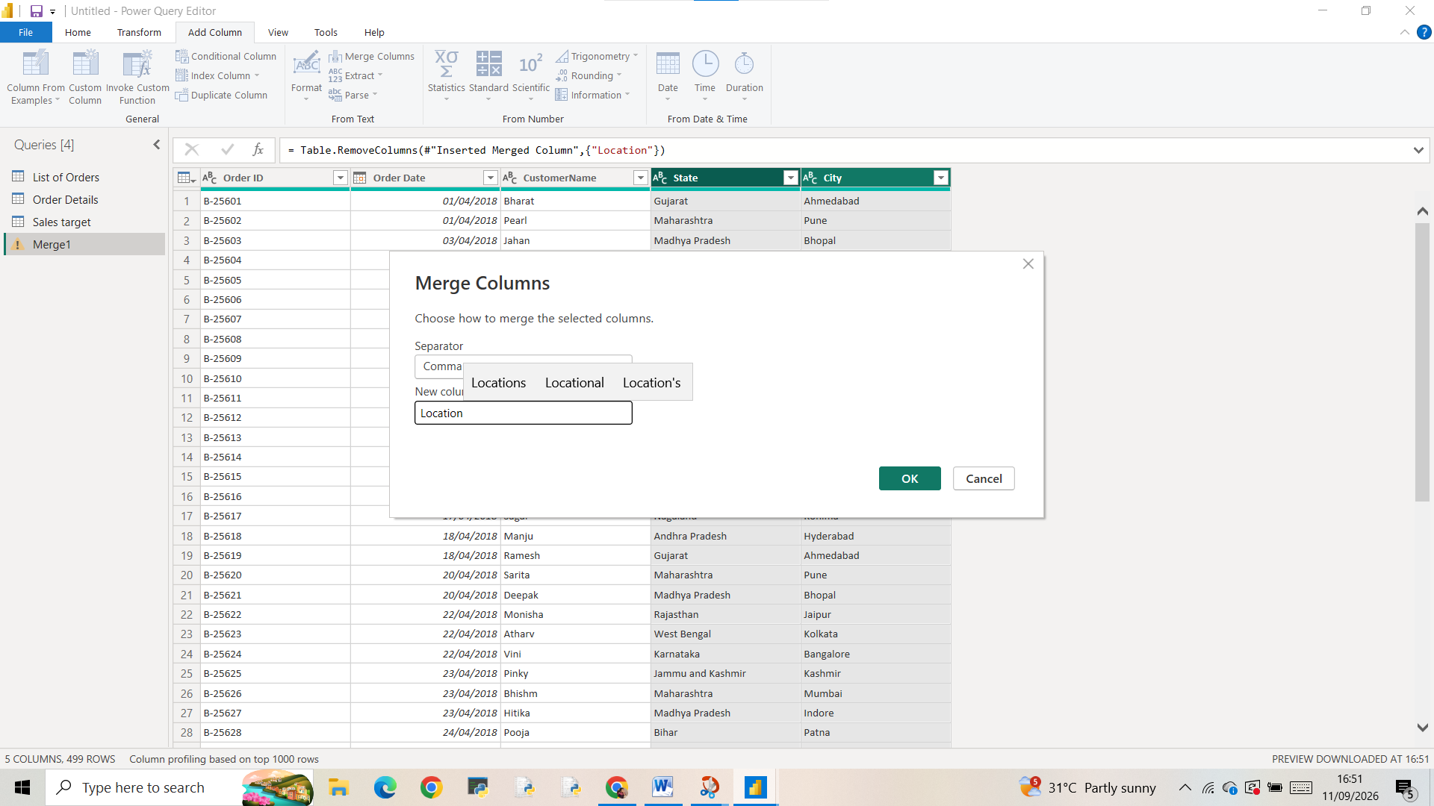

New Custom Column
Create a custom column
Custom column—dialogue box appears—give name as”Profit Margin “—Then give custom column formula then ok
Then we get a column here we want to change data type to percentage
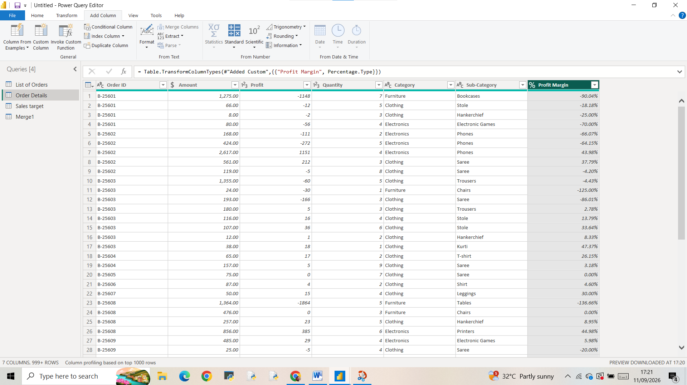
Conditional column

For creating a conditional column—Add columns—conditional columns—Dialogue box appears –we want to give conditions as given in question –we can also add clause –ok .The Result is
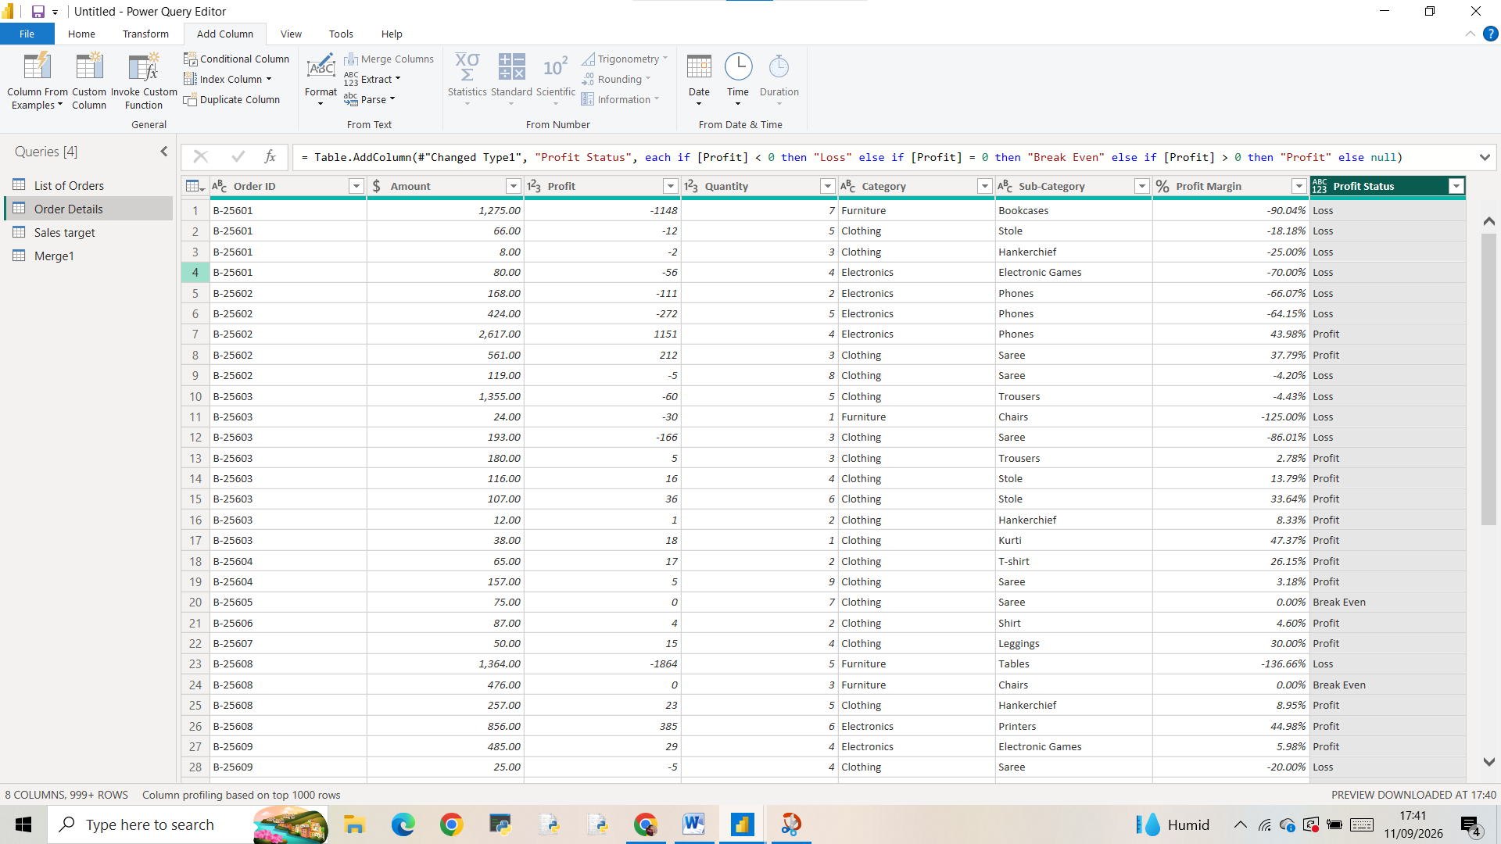

Merging Data (Joins)

For merging data—Home –Merging Queries—Merging queries as new—dialogue box appears –Top table as List of orders and bottom table as select order details join kind as Left outer –ok
Then change the name of merge data as ”Orders data”.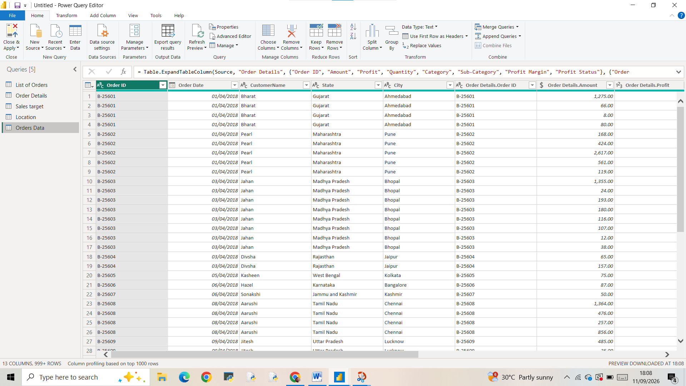
Handling missing data and remove duplicates
For handling missing data in Power BI ,we use a function named COALESCE. Instead of replacing column we can create a new column ,we can replace missing values or unknown (for text),oru use average (for numbers).
Also can use column quality in view tab to check empty columns

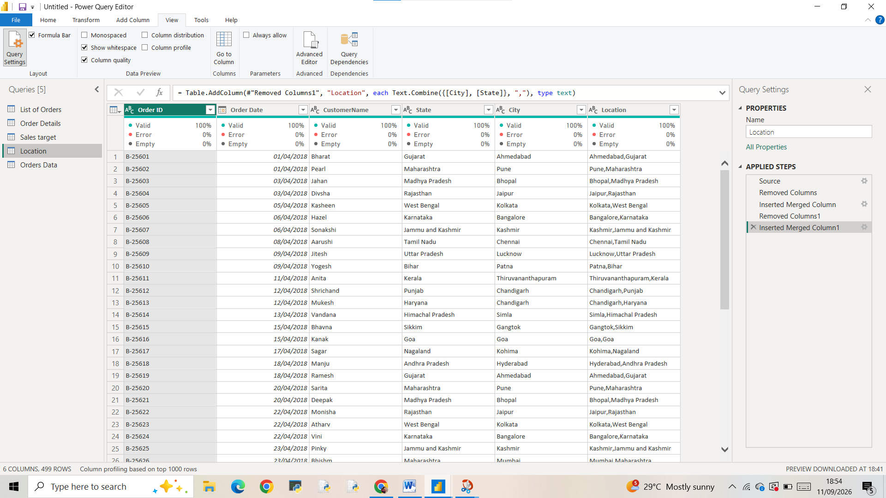
Through these two methods easily replace
But in this data no missing values found.
For checking and removing duplicates we can select column ,right click menu open there we can click keep duplicates then we can found out duplicates and then go to home—remove rows--remove duplicates—ok
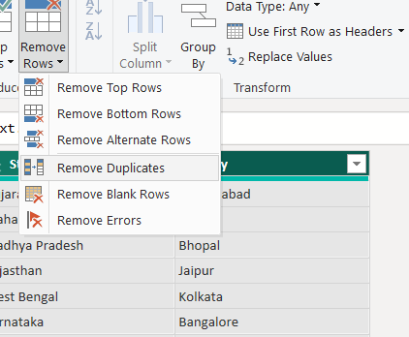

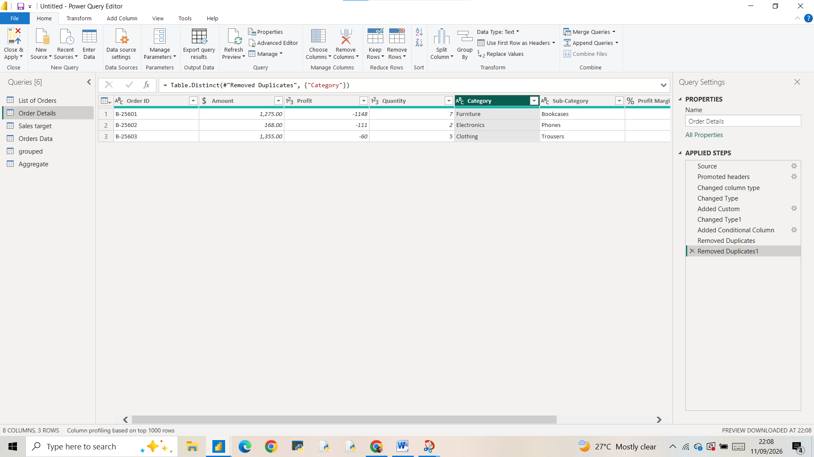

Sorting and Filtering Data
SORTING
Click on order date –click on smalldown arrow on the header—click zort descending
Now date order changed ,totally changed,this shows recent trends first
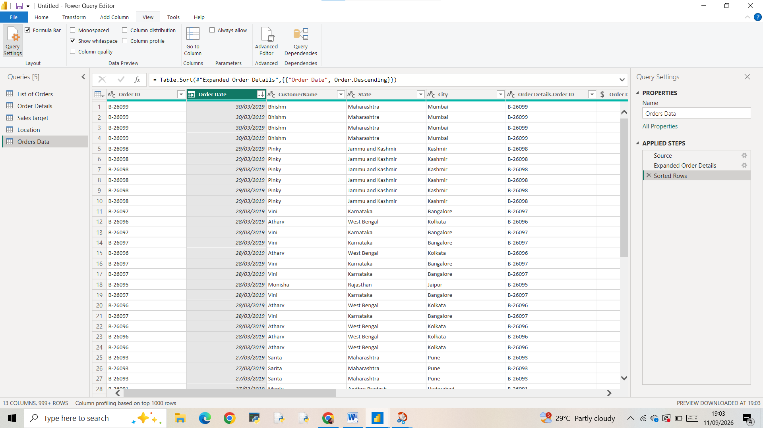
FILTERING
For Filter only Tamil Nadu
Click on state column header—click on small down arrow—unselect all –search for tamil nadu—click it –ok
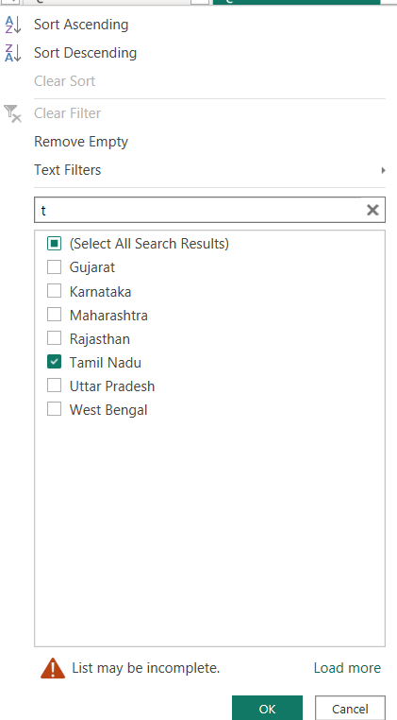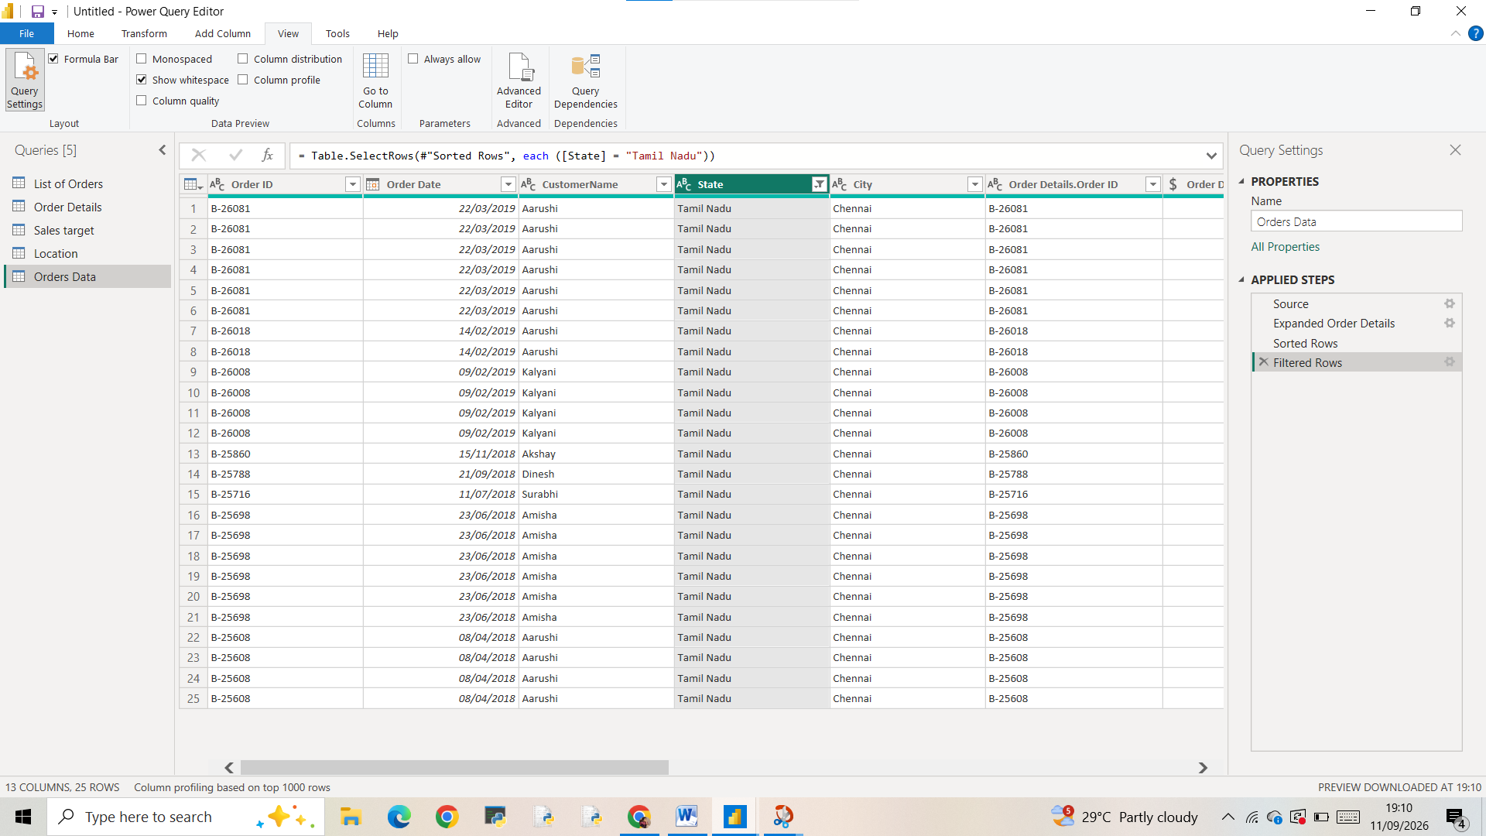

GROUPING AND AGGREGATING

Duplicate order details by-- right clicking order details –menu open –duplicates—renamed it as grouped

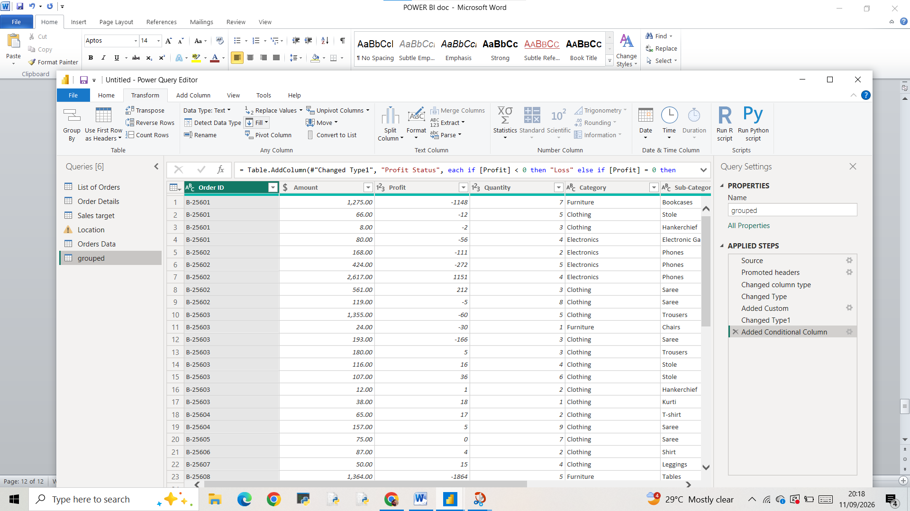

Select Group by in Ribbon then a dialogue box appears there we can select advanced level –there we can select each column ,add grouping,column name ,operation,column evry thinh can be there fill it with according to our question and solve it –ok
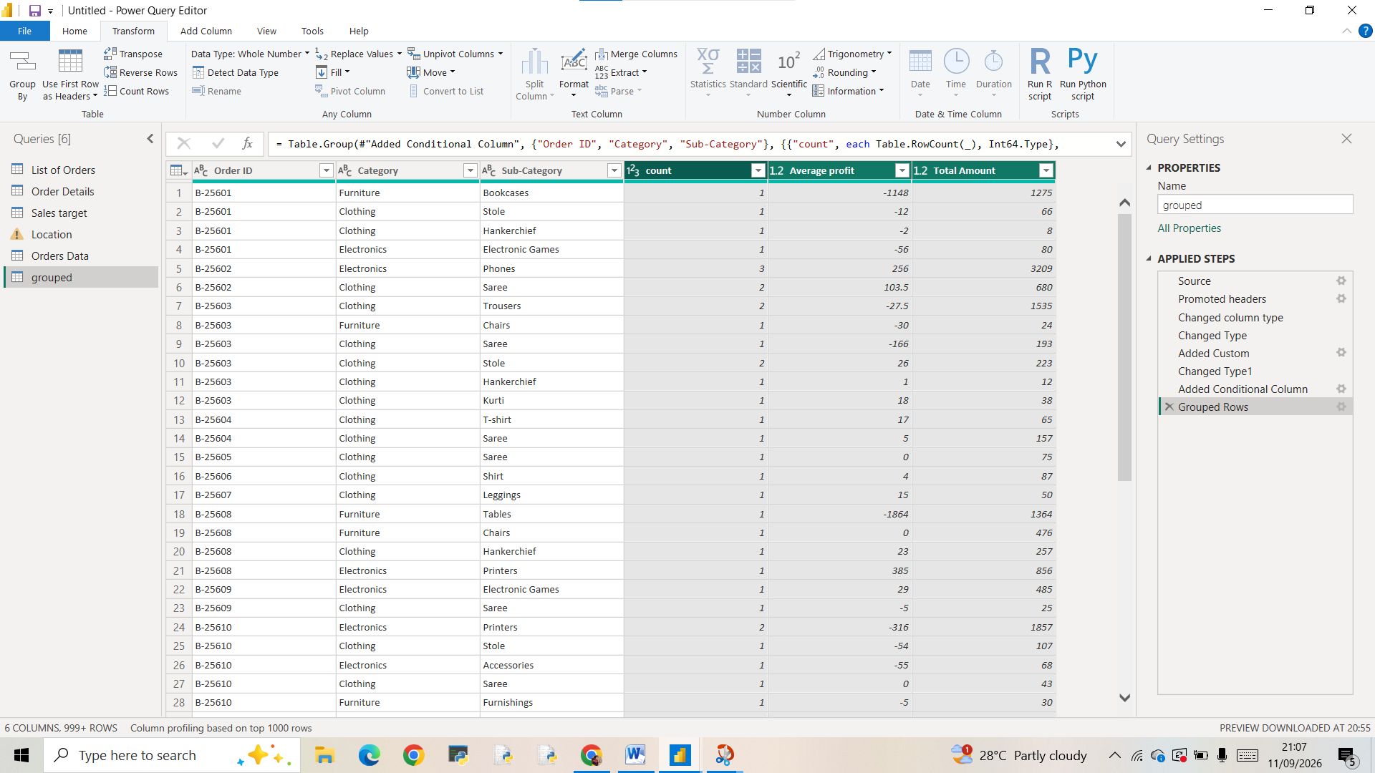

Create a duplicate for sales target and named it aggregate
After that order date is changed to correct date format
Create month column—select order date –go to add column—month—name of month - a new column appears with corresponding months.
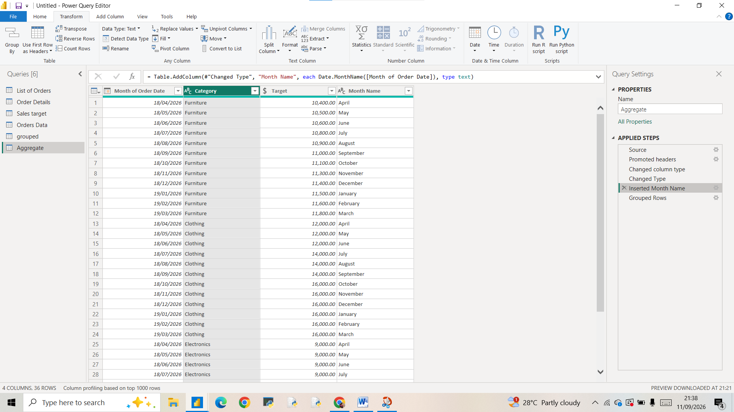

After that Group by—aggregate the total target by month of order date
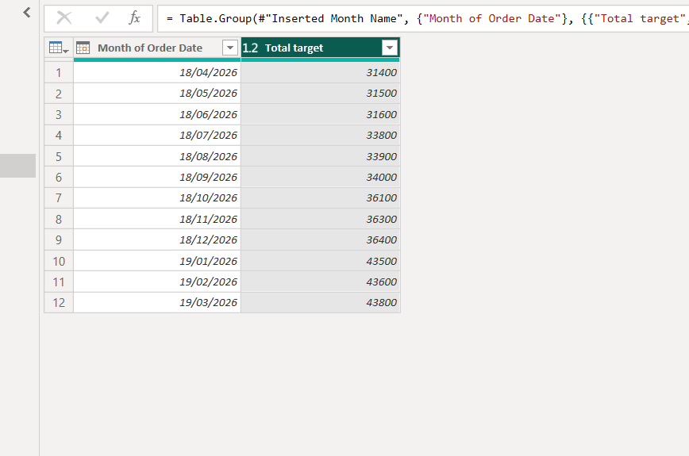

DATA MODELING

Now we can close and apply –power query stops –goes Power BI –go to model view—
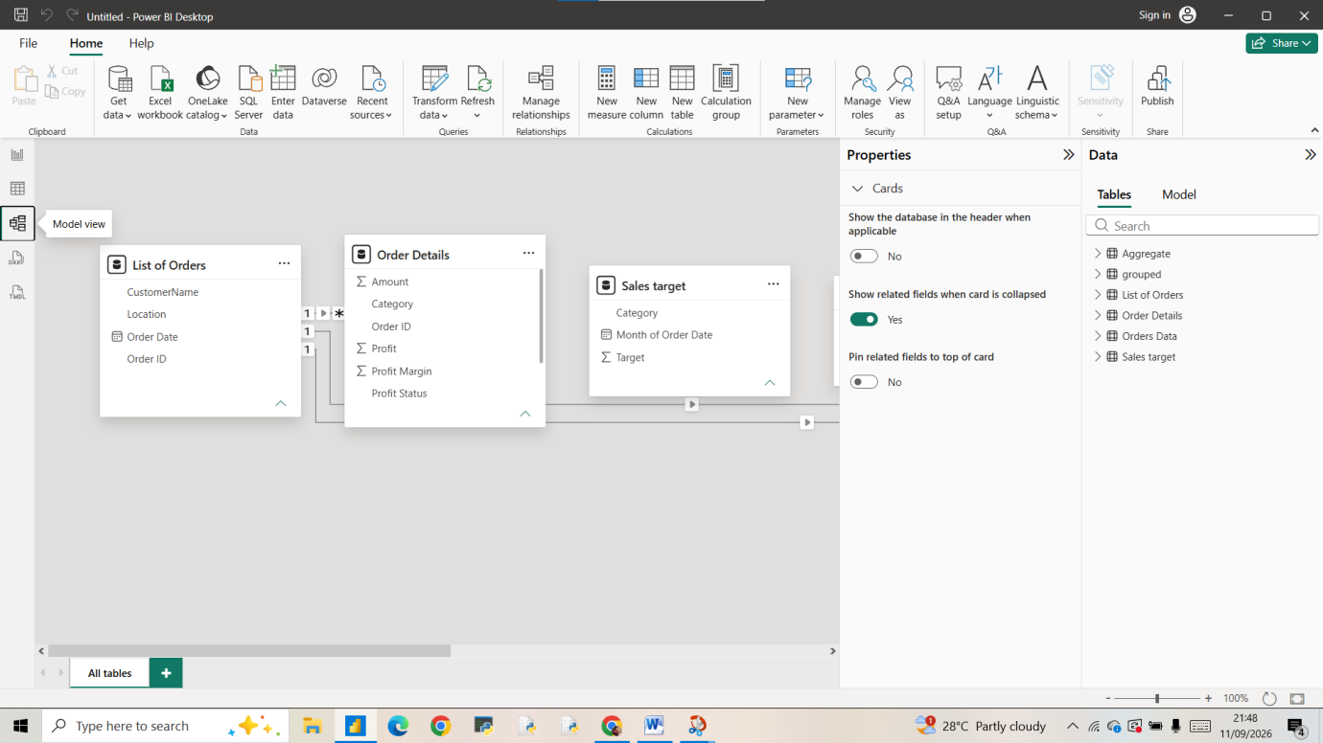

THROUGH MANAGING RELATION SHIP WE CAN MANAGE RELATION SHIP BETWEEN
List of orders and order details using order id column
And also order details and sales target using category column
Manage relation ship and ensured relation ship is active
